# FHIM team meeting, Washington, DC, 13-14 June 2017

Steve Wagner, Steve Hufnagel, Gail Kalbfleisch, Galen Mulrooney, Sean Muir, Rob McClure, John Forester, Jay Lyle

## A Consideration of organizational position of FHIM

1. FHIM within FHA, currently within ONC & HHS
   1. As a Line of Business, it is also under OMB
2. ONC has expressed reluctance to continue to serve as home (sponsor and funder) after 2019
3. Key funders are VA & DoD
   1. Each has some champions
   2. Each also has skeptics who view architecture in general and FHIM in particular as a tax
4. Need to identify options for future organization
   1. HHS CIO office. Use Federal architecture requirements to establish need for CIO (Clinger-Cohen, NDAA/FITARA)
      1. HHS may have directive to focus on security. This might mean a shift in FHIM strategic focus.
   2. NLM considering developing an information model. It may be more efficient for them to adopt FHIM.
   3. VA / DoD / IPO
   4. NIST
   5. Open Group
   6. HL7 US Realm
   7. HSPC/OSEHRA
5. Need to identify stakeholders
   1. to bring us concrete projects that can demonstrate FHIM value
   2. to educate decision makers at possible homes
   3. Includes Operational Divisions
6. Need to identify opportunities to demonstrate FHIM value
   1. Develop communication plan
      1. Objectives, targets, messages, channels, tasks
      2. Address “FHIM has outgrown federal agencies”
      3. Samantha Mergenthaler, tech writer can help
      4. Educate potential stakeholders
      5. Develop contract language
   2. Get CIMI September ballot to use FHIM to generate FHIR resources
   3. Get CIMI-interested projects to use FHIM
      1. Podiatry
      2. Exercise medicine (THEMES)
   4. Encourage HL7 US Realm SC to use FHIM as reference model, repository, & generator for US realm specifications, viz., FHIR profiles
   5. DoD: align with PAMPI (problems, allergies, medications, procedures, immunizations) priorities
   6. Identify how FHIM can assist with quality framework
      1. Include quality measures (Julia Skapik)
      2. Include VA KNART efforts (Lorraine Constable, Patrick Lloyd)
   7. Engage FHA provider directory project
      1. Re-start FHIM domain
      2. Support FHIR profile generation
      3. Existing specifications include NUCC provider taxonomy, CMS National Plan and Provider Enumeration System (NPPES), and Medicare Provider Enrollment, Chain, and Ownership System (PECOS)
   8. Enhance FHIM web site to make it accessible & make value proposition clear
      1. ONC does not plan to fund site
      2. Consider using existing unpublished JPSys design
      3. Consider using GitHub

## B CIMI alignment

1. Plan to get FHIM model to point where BMM can be generated
2. FHIM may contain more than CIMI
3. Need to get CIMI archetypes back into FHIM
   1. To publish for human review
   2. To support model-driven generation of FHIR profiles
4. Note CIMI archetypes need to be in a separate package so as not to interfere with BMM generation
5. Gaps
   1. Data type alignment
   2. Demographics (CIMI ISO 13606 “party” pattern; FHIM uses RIM role pattern

## C Tooling

1. Current State
   1. FHIM is a UML model - .uml, .emf, .mdd, etc.
      1. Can be decomposed into more granular files for version control & coordination of change control
   2. Modeling tools can modify
      1. 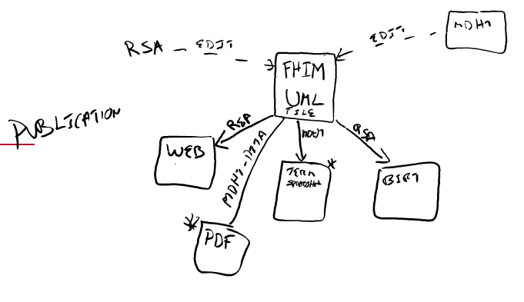RSA, Papyrus, etc.
      2. EA uses Access natively, but can export or import uml files
   3. MDHT can also modify
   4. RSA exports
      1. Web publication (EA may be more flexible)
      2. BIRT reports
   5. MDHT generates
      1. DITA Documents
      2. 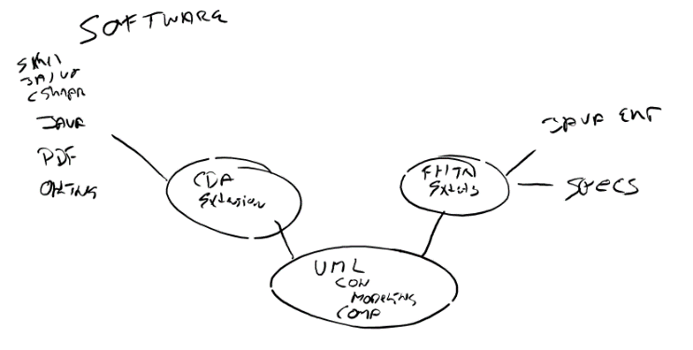Terminology reports
2. Future state
   1. MDHT supports generation of java classes, schematron, and other computable artifacts based on the uml, for both CDA and FHIR.
   2. This has been done using UML profiles, but this approach has not proven to be scalable.
   3. It is now being done with the Model Driven Messaging Infrastructure (MDMI) referent index.
   4. This is a viable option for supporting the CIMI September ballot.
3. FHIM does not contain requirements. Should it?
   1. Detailed use case analysis is not recommended.
   2. It is asserted that FHIM maps to the EHR system functional model. [where?]

## D SOLOR

1. SOLOR will support CIMI semantics, so to the extent FHIM supports CIMI, it supports SOLOR, just as it supports terminology for FHIR, V2, and C-CDA.
2. Because CIMI will use SOLOR for model semantics as well as value sets, and because SOLOR could ingest or map the values for other specifications, SOLOR could provide a semantic foundation for FHIM in other contexts as well.
3. Target release of SOLOR at the end of October.
4. SOLOR will support refset definition of value sets; these can be published as refsets via HSPC’s server (OntoServer) or as value sets in VSAC.

## E Action Items

1. Tactical
   1. Plan FHIM support for CIMI ballot
      1. Confirm BMM generation, terminology access, how MDHT/MDMI can use ADL archetypes; coordinate with CIMI team
   2. Enhance web site to support primary FHIM value message, asset browsing
   3. Engage Provider directory project
   4. Engage other projects as appropriate (Podiatry, THEMES exercise medicine project)
2. Strategic
   1. Identify & qualify likely organizational homes & stakeholders
   2. Establish communication plan